Sprint 4 Status Report
For the Girl Scouts of America Badge Tracking
Application

By
Matt Eck
Michael Glosecki
Nathan Martz
Ryan Schroeder

Of
Team Cookie Council

1. The Council estimated 84 hours to complete sprint 4 however the sprint took us 81.5 hours. After the sprint was completed we had 0 hours left on the story tasks selected.

2. All stories on product backlog were selected for Sprint four. The goal of sprint four was to continue working on the web page and get started on mobile development.
- PHP badge tracking page made by Mike
- PhoneGap was researched and Used by Matt & Ryan
- User interface Re-Factored on dry erase board by Matt, Nate, and Ryan
- Web design updated and improved by Nate
- Presentation slides were prepared and practiced by all members

3. Client offered an option for a server through the Scout Council. The client was contacted each week requesting signatures on the Specifications and Plan. The Client responded once with a signed project Specifications. Meetings were requested but with no confirmation from client.

4. Risks mitigated this Sprint was the lack of mobile development knowledge. The team mitigated this risk by using PhoneGap and their existing Web site to generate a phone app. The team felt as though with our current knowledge and PhoneGap we should have no problem producing a Mobile application.

Project Burndown chart
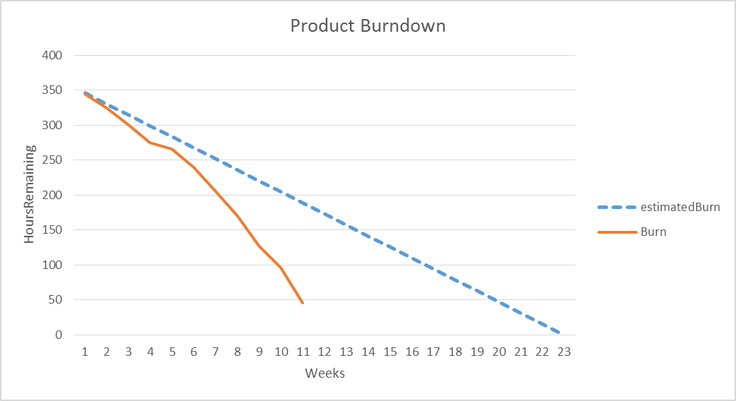

Sprint Burndown Chart
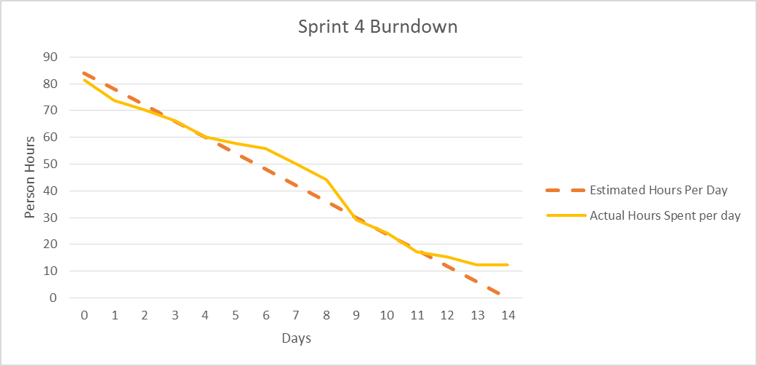

Weekly Development Effort
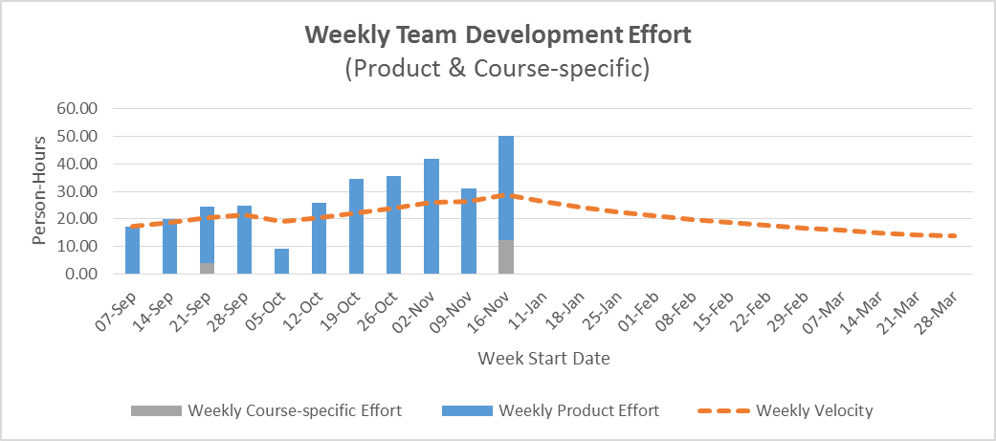

Daily Team Effort
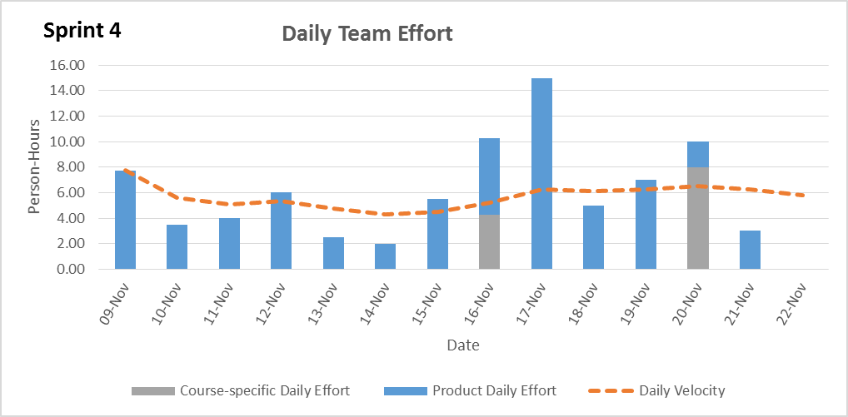

Team Member Effort

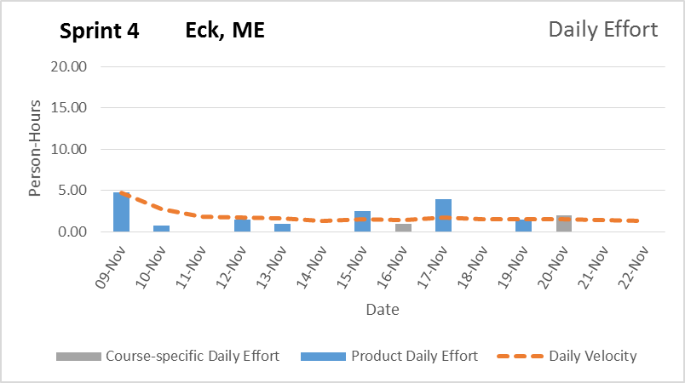
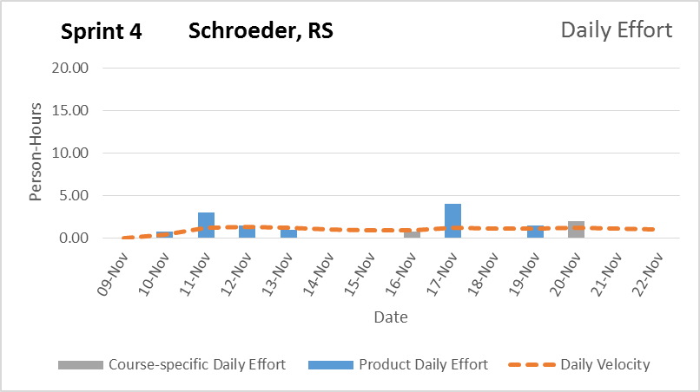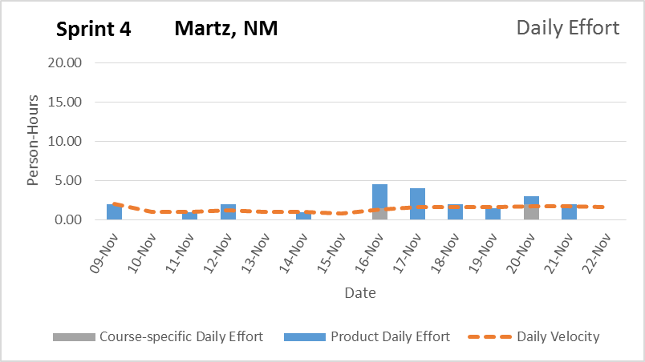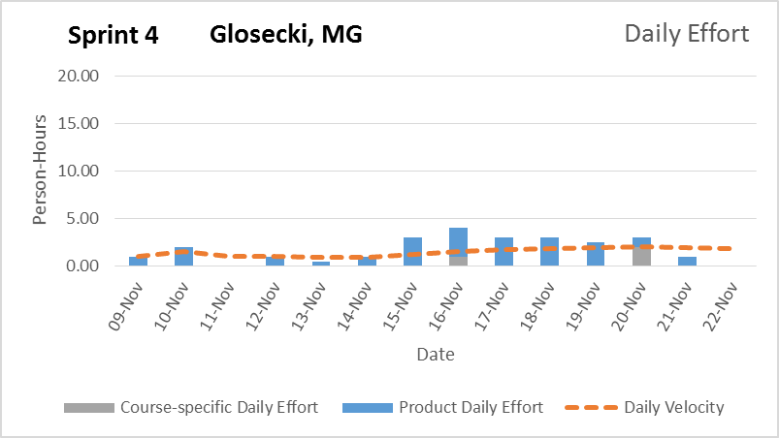

6. The team is confident that the product will be delivered to the client within the time frame with all functionality implemented. Our product Burn down shows that our progress is a bit behind but we feel that this is due to poor estimations of tasks. We intend on re-evaluating these time estimations at the beginning of the next sprint (semester), so this will not continue to be a problem.

Signature Date

__________________________________________ ______________

__________________________________________ ______________

__________________________________________ ______________

__________________________________________ ______________

